CONTRAST ISSUE 1
CONTRAST ISSUE 2
CONTRAST ISSUE 3

FONT ISSUe 1

rtertertertert

wow

wow

Fwerwerwerwerefrwerwer
Werwqerw
Rweq

123

dfasfasf
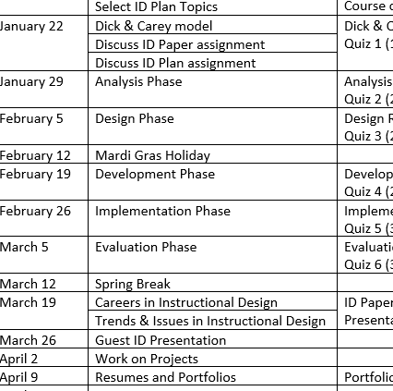
Rqwerwqerwqerwerqwer
Werweqr ewqerwqer werwqr werwqe

Werwerwerwer

TEST HEADING

dfwefrqwe

weqweqw

TEST HEADING 2

TEST

TEST

Eqweqweqwe

1.ghhyguqwer
2.hgdhgqwejhr
- Hgdhgdwfjhw
sdasf
4.ghdhwjegrhjw

Dfvasdfasdfasdf

Rtgstertertert

rertertert

Erwerwerwerewrewrwe

learn more about Gmail

gfhwegfrhqwejktrhwekljr

gfhwegfrhqwejktrhwekljr

Elizabeth - Google Search Google search engine





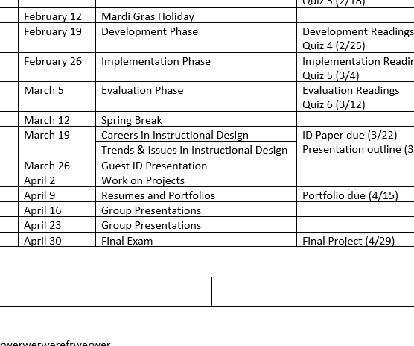

Accessibility Issue: List Not Properly Formatted
- Apples
- Bananas
• Cherries

- Test
- test 2
2. hjwhedjqw

Accessibility Issue: List Not Properly Formatted
- Apples
- Bananas
• Cherries

- Test
- test 2
- hjwhedjqw

